**Practical No 7**

**Aim:** Write a program for web feed.

Step 1: Now write the following code and save as rss.xml file.

Xml Code.

<?xml version="1.0" encoding="UTF-8"?>

<rss version="2.0">

<channel>

<title>W3Schools Home Page</title>

<link>https://www.w3schools.com</link>

<description>Free web building tutorials</description>

<item>

<title>RSS Tutorial</title>

<link>https://www.w3schools.com/xml/xml_rss.asp</link>

<description>New RSS tutorial on W3Schools</description>

</item>

-<item>

<title>XML Tutorial</title>

<link>https://www.w3schools.com/xml</link>

<description>New XML tutorial on W3Schools</description>

</item>

</channel>

</rss>

Step 2: Open visual studio and click on File ̶˃ new ̶˃ website ̶˃ visual C# ̶˃ ASP.NET website ̶˃ OK

Step 3: Now copy rss.xml file in it.

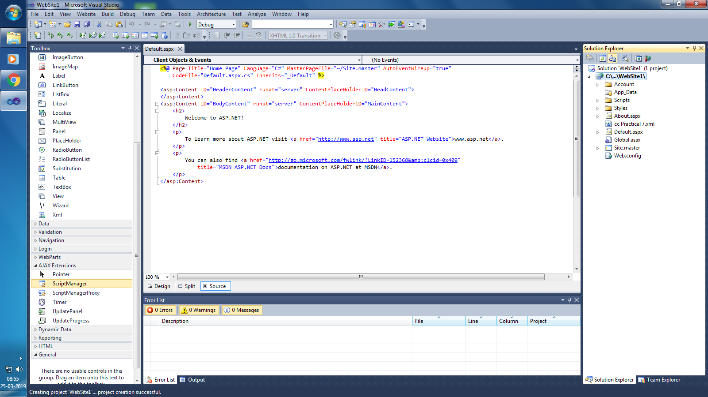

Step 4:Now write following line before ending tag.

<p>here is ur <a href="rss.xml">feed</a>.</p>

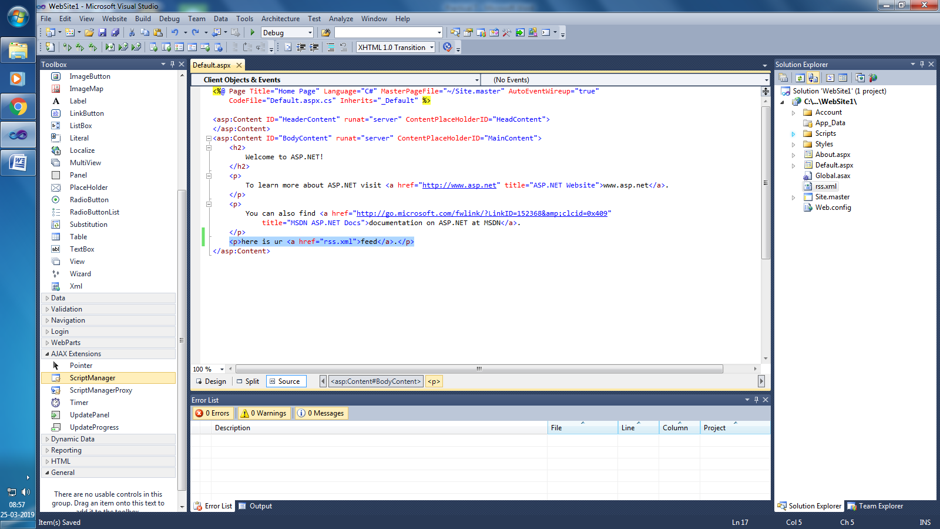

Step 5: Now run the file.

